**Code Complexity Tool User Guide**

1. Finding complexity of an entire Project

* 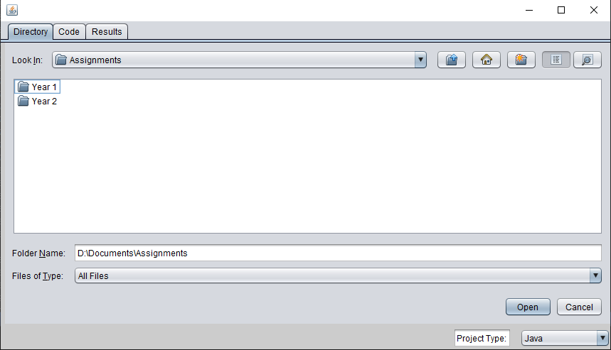To measure the code complexity of an entire project, first run the program.
* 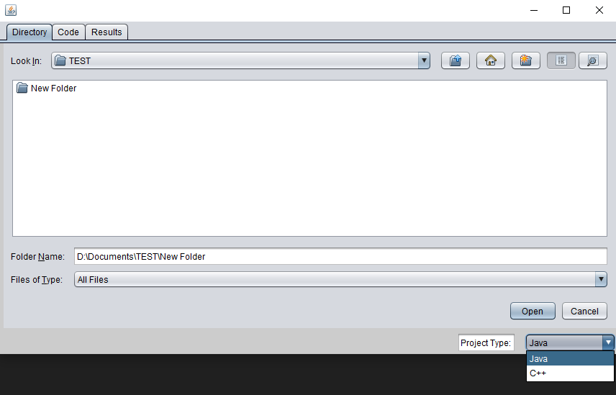Navigate to the folder where your project is located and select the type of project from the drop-down list.
* 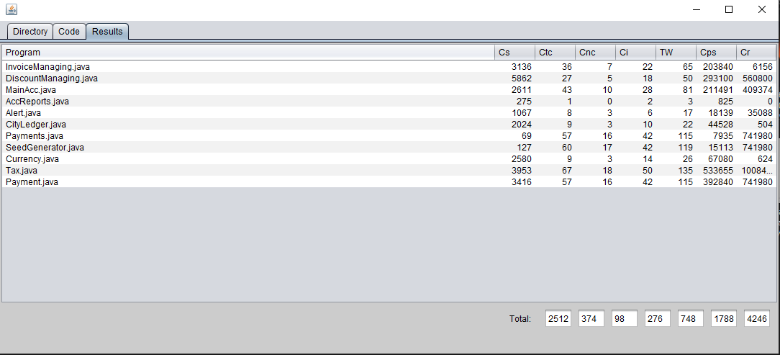Press ‘open’ to run the program and obtain scores on a file by file basis.

1. Finding complexity of code

* 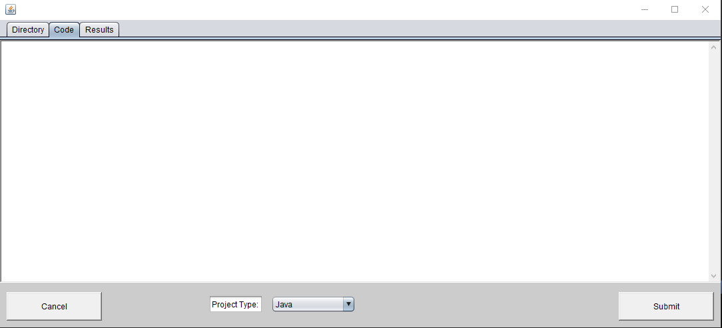To measure the complexity of a code, first run the program and switch to the ‘code’ tab.
* 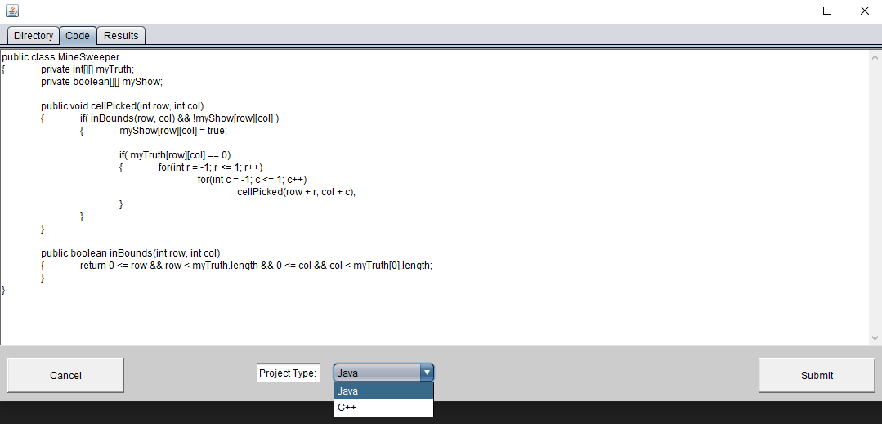Then paste the code and select the language of the code.
* Submit the code to get result line by line.